Survival Analysis
Name
Institution
Date

Survival Analysis
Survival analysis offers a comprehensive understanding of the efficacy of a given intervention. In experimental studies, there is a crucial need to evaluate the success of a given intervention. The treatment intervention is assessed within a given time where an outcome is determined. The outcome in this context is either the subject dies or stays alive until the curve is flattened. The assessment of time taken to reach an outcome offers more comprehensive knowledge on the efficiency of an intervention that is being assessed. In some cases, both mortality patterns and treatment outcomes can be investigated simultaneously. Time to event is essential in time series analysis since it presents a more accurate representation of the specific concepts that are being assessed.
Therefore, the study seeks to determine whether the risk of dying is associated with the patient treatment group in this context. Thus, it is imperative to conduct survival analysis in determining the efficiency of a given treatment as well as investigating mortality patterns. The assumption has been effectively outlined, which forms the basis of analysis. Cox proportional hazards regression model is essential in analyzing the effects of risk factors on survival (Austin, 2017). The time aspect that is investigated in this case is serial time in years; the status is the event occurring. The independent variable that is assessed in this case is the treatment intervention. The treatment intervention is grouped into either chemo or placebo (control group).
Results

Case Processing Summary
 |  | N | Percent
Cases available in analysis | Event | 10 | 83.3%
Cases available in analysis | Censored | 2 | 16.7%
Cases available in analysis | Total | 12 | 100.0%
Cases dropped | Cases with missing values | 0 | 0.0%
Cases dropped | Cases with negative time | 0 | 0.0%
Cases dropped | Censored cases before the earliest event in a stratum | 0 | 0.0%
Cases dropped | Total | 0 | 0.0%
Total |  | 12 | 100.0%
a. Dependent Variable: Serial Time (years)

The analysis shows that there were 2 individuals who were still alive by the end of the study, representing 16.7%.

Omnibus Tests of Model Coefficients
-2 Log Likelihood | Overall (score) |  |  | Change From Previous Step |  |  | Change From Previous Block
-2 Log Likelihood | Chi-square | df | Sig. | Chi-square | df | Sig. | Chi-square | df | Sig.
33.653 | 2.853 | 1 | .091 | 2.682 | 1 | .101 | 2.682 | 1 | .101
a. Beginning Block Number 1. Method = Enter

The omnibus test of the model shows that the p = 0.091, which means that the model fit was efficient in predicting the outcome investigated.

Variables in the Equation
 | B | SE | Wald | df | Sig. | Exp(B) | 95.0% CI for Exp(B)
 |  |  |  |  |  |  | Lower | Upper
Group (1 Chemo or 2 Placebo) | -1.200 | .748 | 2.575 | 1 | .109 | .301 | .070 | 1.304

The study sought to investigate whether the treatment group influences the outcomes. However, the results show that at a 95% confidence level, the group does not significantly predict the outcome.
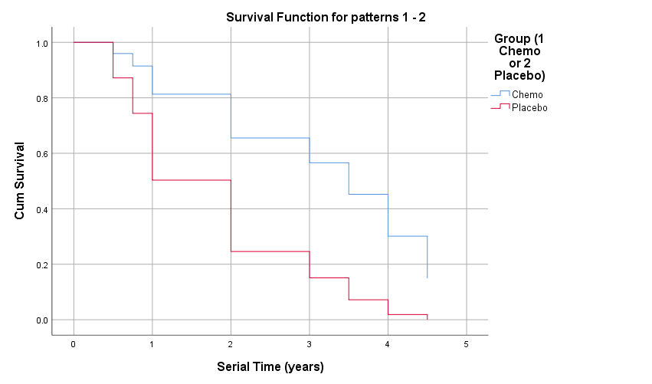
The survival analysis plots show a difference in serial time between the chemo and placebo group. The chemo group is shown to have a higher chance of survival compared to the placebo group.
Discussion and conclusion
The findings from the analysis have shown that even though the results are not significantly different between chemo group and placebo group based on the serial time. There is a difference in serial time between the groups based on the survival analysis plots. Patients who underwent chemo had a higher chance of survival compared to patients in the placebo group. According to Issels et al. (2018), investigating the implication of neoadjuvant chemotherapy and regional hyperthermia on long-term outcomes among patients showed that patients who were enrolled in the chemotherapy group had a prolonged survival rate with a 62% five-year survival rate. Similarly, Chikhladze et al. (2019) found that patients' survival after adjuvant chemotherapy was increased compared to that of patients without chemotherapy. Chemotherapy has been associated with improved outcomes, which present a broader basis within which it is possible to make informed decisions regarding the patient's wellbeing. It would be essential to consider chemotherapy for patients with this condition because of the slight increase in the seral time compared to the placebo group.

References
Austin, P. C. (2017). A tutorial on multilevel survival analysis: methods, models and applications. International Statistical Review, 85(2), 185-203.
Chikhladze, S., Lederer, A. K., Kousoulas, L., Reinmuth, M., Sick, O., Fichtner-Feigl, S., & Wittel, U. A. (2019). Adjuvant chemotherapy after surgery for pancreatic ductal adenocarcinoma: retrospective real-life data. World journal of surgical oncology, 17(1), 1-11.
Issels, R. D., Lindner, L. H., Verweij, J., Wessalowski, R., Reichardt, P., Wust, P., ... & Gronchi, A. (2018). Effect of neoadjuvant chemotherapy plus regional hyperthermia on long-term outcomes among patients with localized high-risk soft tissue sarcoma: the EORTC 62961-ESHO 95 randomized clinical trial. JAMA oncology, 4(4), 483-492.

